Chapter 10, Solution 30.

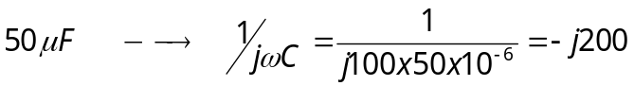
The circuit becomes that shown below.

j40 j20
20 Ω
+
_
+
_

+
120∠90º 10 Ω
I₁ j30 –j200 v_{o} I_{3`}

I₂ -
80∠0º

For mesh 1,
(1)
For mesh 2,
(2)
For mesh 3,
(3)

We put (1) to (3) in matrix form.

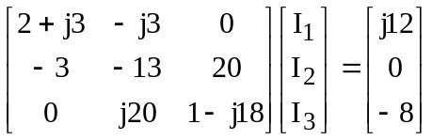

This is an excellent candidate for MATLAB.

>> Z=[(2+3i),-3i,0;-3,-13,20;0,20i,(1-18i)]

Z =

2.0000 + 3.0000i 0 - 3.0000i 0
-3.0000 -13.0000 20.0000
0 0 +20.0000i 1.0000 -18.0000i

>> V=[12i;0;-8]

V =

0 +12.0000i
0
-8.0000

>> I=inv(Z)*V

I =

2.0557 + 3.5651i
0.4324 + 2.1946i
0.5894 + 1.9612i

V_{o} = –j200(I₂ – I₃) = –j200(–0.157+j0.2334) = 46.68 + j31.4 = 56.26∠33.93˚

v_{o} = 56.26cos(100t + 33.93˚) V.

